**GUI DESIGN**

**Order Menu**

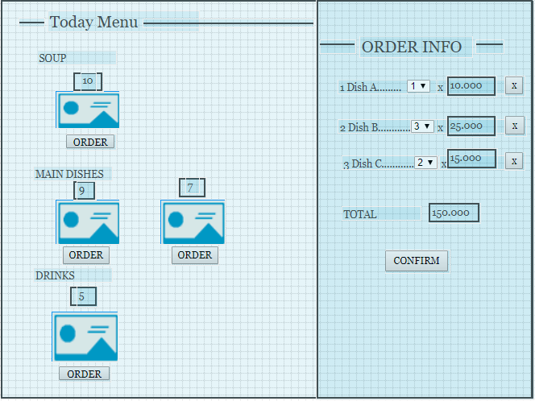

|  |  |
| --- | --- |
| Purpose | Showing dishes (in general and details) and allowing customers order dishes, then creating bills |
| Connect From | Menu bar |
| Connect to | Order Info |
| Validation | * **Dish on bill** * If existed, order button on that dish has no function * **Quantity each dish** * Be able to adjust up/down * Minium value: 1 * Maxium value <= available quantity * **Confirm** * Alert customers about their decisions |
| Initial values | * Dishes Info * Quantity value (minium 1) of each dish on bill * Price each dish * Value in total of bill |
| Events | * Click Order to add a dish on bill * Adjust quantity of each dish on bill * Click “X” on bill to remove a dish * Click confirm to redirect to Order Info page * After each order’s succeed, quantity available lying above on each dish will reload and be updated. |

**Order Info**

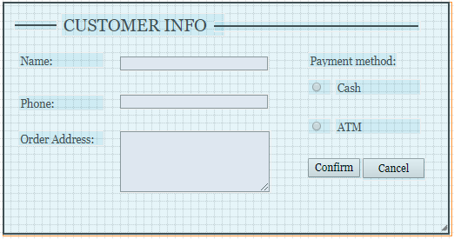

|  |  |
| --- | --- |
| Purpose | Ask more information about Order info to complete order |
| Connect From | Order menu |
| Connect to | Order succeed confirm (showing order details)  If ATM is chosen, link to payment gateway |
| Validation | * **Customer name** * Not blank * 4 - 100 characters * **Phone** * Not blank * 10 – 11 characters * Format: “09XXXXXXXX” * **Order address** * Not blank * 50 – 200 charaters * Suggestion type ahead (Street) |
| Initial values | * If it is the second booking, the customer detail shows automatically * Cash option is default |
| Events | * Click Confirm to complete an Order and send email with Order detail content. |